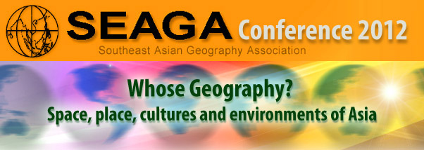

27 – 30 November 2012
Singapore

SEAGA Conference 2012 in Singapore
SEAGA, the Southeast Asian Geographers Association, established in 1990, is a regional association of geographers and other academic, education, government, and private sector professionals in related fields like history, the geo- and environmental sciences, and urban planning. The 2012 conference will be the 11th conference that has been organized by SEAGA.

Conference Theme
The conference theme is: “Whose Geography? Space, place and cultures of Asia” and we are inviting multidimensional perspectives on this issue from scholars, policy makers, entrepreneurs, and teachers. The aim of the conference is to advance the discourse on the issues of space, place and cultures in Asia, so as to inform the decision-making and actions of society, private enterprise, and governments. This theme was chosen based on the recommendation of the delegation to the previous SEAGA conference in Hanoi as they felt that there was a need for the community to address these geographical issues from multiple perspectives.

First Call for Papers
This is a first call for papers on the following themes. Abstracts of paper/ workshop/panel proposal are to be submitted to the SEAGA Conference Organising Committee, using the online submission tool at http://www.seaga.info/seaga2012/
The submission deadline will be 31 May 2012. Acceptance letters will be sent after 30 June 2012. All submissions will be peer reviewed.

Three types of proposals will be considered.
- Paper presentation (20 minutes)
- Specialised Panel Discussions (90-minute session comprising 3 papers)
- Workshops (90-minute workshop)

Do note that for paper presentations, there will be about 3 papers in each 90 minute session and a discussant will critique and lead a discussion of the papers after all papers have been presented. To facilitate this, we will need full papers to be submitted by 1 October to the programme committee. A template for full paper will be made available at a later date.
Major themes of interest:
- Changing Physical Landscapes in Southeast Asia
- Living with Global Environmental Change
- SE Asia and Environmental Management
- Changing Population, carrying capacities and ecological footprints
- Sustainable Development and Southeast Asia
- Politics, policies and sustainability
- Health and development issues
- Cities and sustainable development
- Economic growth, competitiveness and sustainable development
- Changing Agriculture in SE Asia
- Geographies of rural transition
- New regionalisms in Southeast Asia
- Sustainability and Education
- Geography Education
- Field-based teaching in Southeast Asian geography
- Remote sensing and GIS: their contribution to environmental management in southeast Asia

More information about registration will be available in Spring 2012. Please visit http://www.seaga.info/ You can also subscribe to the RSS feeds for the latest updates at http://www.seaga.info/rss/all.xml.

